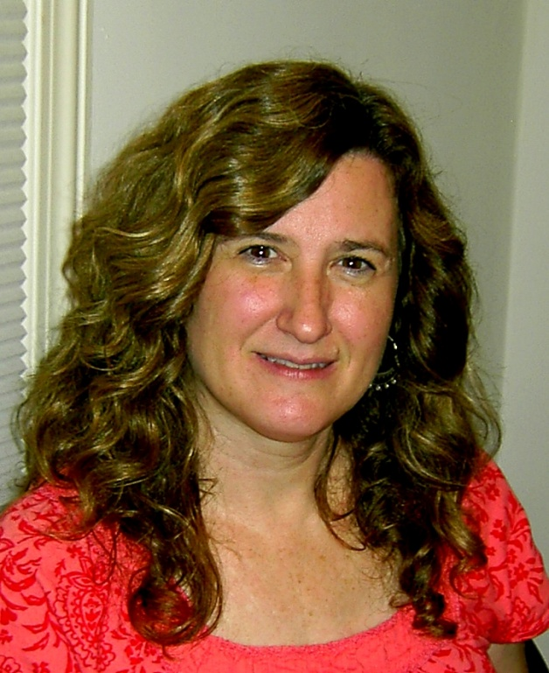
Paula Smith was born in Kansas City, Missouri. She attended the Kansas City Art Institute and received her Bachelor of Fine Arts in 1982, continuing her education at the University of Illinois and received her MFA in 1986. She and her husband moved to Rock Hill, SC, in 1987, where she began teaching part time at Winthrop University for 13 years and in that time owned and operated the Oakland Art Supply store for 9 years.
She continued on to teach full time at Gaston College for 9 years and now resides as the head of the ceramics department at Central Piedmont Community College in Charlotte, NC. Paula exhibits nationally and her work is on view full time at the Lark and Key Gallery, in Charlotte.
Among many other accomplishments, Paula just received a public art commission from the Arts and Science Council of North Carolina. She was an 18 month affiliate artist at McColl Center for Visual Art, in Charlotte; has received numerous Artist Grants from both North and South Carolina Arts Councils including a South Carolina Fellowship Grant and was a resident artist for a month in China at the Potters Workshop in Shanghai and at San Boa, in Jingdezhen. She loves to travel, bake, garden, and give fun parties.

